BLADDER TANK VERTICAL PENTRU SPUMA CU MEMBRANA INTERNA
VERTICAL FOAM BLADDER TANK INTERNAL MEMBRANE
Mod. FI-PI

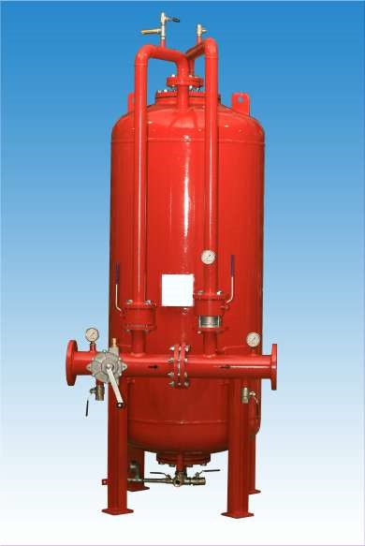
Caracteristici tehnice constructive | Technical construction data
- Norma: 2014/68/UE (Ex. PED 97/23/CE), ASME VIII Div.1 la cerere | - Construction code: 2014/68/UE (Ex. PED 97/23/CE), ASME VIII Div.1 on request
- Presiune de design: 12 bar | - Design pressure: 12 bar
- Presiune maxima de lucru: 12 bar | - Max working pressare: 12 bar
- Presiune de test: 18 bar | - Test pressure: 18 bar
- Temperatura de design: -10° + 50°C | - Design temperature: -10° +50°C
Data Sheet N°50
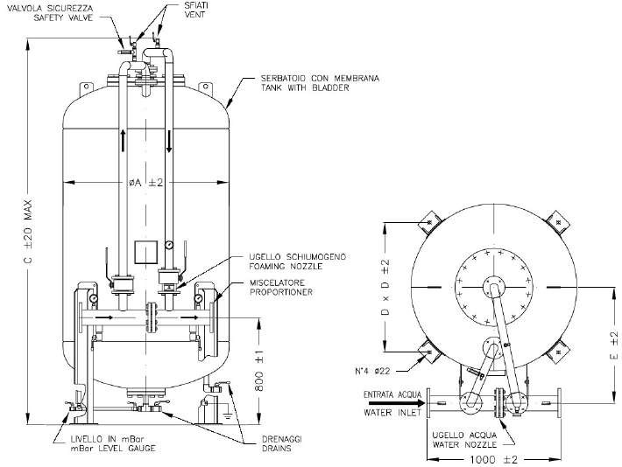

Caracteristici tehnice constructive | Technical construction data
Material | Materials
- Capac: P355 NH | - Shell and head: P355 NH
- Flanse: ASTM A 350 LF2 (UNI o ANSI) | - Flange: ASTM A 350 LF2 (UNI o ANSI)
- Teava: ASTM A 333 Gr.6 | - Pipe: ASTM A 333 Gr.6
- Valva apa si spuma: ASTM A 105 cu sfera in AISI 304 | - Water and foam ball valve:  ASTM A 105 with ball in AISI 304
- Valva drenaj: Alama | - Drain and intercept valve: Brass
- Manometru: AISI 304 | - Pressare gauge: AISI 304
- Duze apa si spuma: Otel inoxidabil | - Water and foam nozzles: Acciaio inox
- Membrana: Hypalon | - Bladder: Hypalon
Ciclu de vopsire | Painting cicle standard
- Preparare: sabbiatura SA 2,5 | - Surface preparation: sand blasting SA 2,5
- Prima mana: Epoxivinilic  60 Microns | - Primer: Epoxivinilic 60 Microns
- Final: Email poliuretanic 60 Microns rosu RAL 3000 | - Finish: Enamel poliurethanic 60 Microns red RAL 3000

La cerere rezervoarele se pot furniza cu diferite valori de presiune
On request tanks can be supplied with different pressure values

TABEL DIMENSIUNI
DIMENSIONAL TABLE
MODELLO MODEL | MISURE – DIMENSION |  |  |  | PESO MAX A VUOTO Kg.  MAX EMPTY WEIGHT Kg. | CAPACITA’ Lt.  CAPACITY Lt.
MODELLO MODEL | A | C | D | E | PESO MAX A VUOTO Kg.  MAX EMPTY WEIGHT Kg. | CAPACITA’ Lt.  CAPACITY Lt.
FI-PI5 | 800 | 1955 | 624 | 650 | 415 | 500
FI-PI6 | 800 | 2165 | 624 | 650 | 455 | 600
FI-PI8 | 800 | 2565 | 624 | 650 | 490 | 800
FI-PI10 | 1000 | 2248 | 790 | 750 | 525 | 1.000
FI-PI15 | 1000 | 2838 | 790 | 750 | 615 | 1.500
FI-PI20 | 1100 | 3109 | 864 | 800 | 880 | 2.000
FI-PI25 | 1170 | 3339 | 914 | 800 | 965 | 2.500
FI-PI30 | 1270 | 3372 | 984 | 860 | 995 | 3.000
FI-PI35 | 1360 | 3412 | 1048 | 900 | 1095 | 3.500
FI-PI40 | 1450 | 3450 | 1112 | 950 | 1300 | 4.000
FI-PI45 | 1450 | 3715 | 1112 | 950 | 1380 | 4.500
FI-PI50 | 1600 | 3536 | 1245 | 1050 | 1545 | 5.000
FI-PI55 | 1600 | 3751 | 1245 | 1050 | 1620 | 5.500
FI-PI60 | 1750 | 3603 | 1351 | 1150 | 1695 | 6.000
FI-PI65 | 1750 | 3734 | 1351 | 1150 | 1735 | 6.500
FI-PI70 | 1750 | 3953 | 1351 | 1150 | 1825 | 7.000
FI-PI75 | 1750 | 4164 | 1351 | 1150 | 1900 | 7.500
FI-PI80 | 1960 | 3749 | 1534 | 1200 | 2300 | 8.000
FI-PI85 | 1960 | 3899 | 1534 | 1200 | 2370 | 8.500
FI-PI90 | 2100 | 3821 | 1636 | 1300 | 2495 | 9.000
FI-PI100 | 2200 | 3873 | 1707 | 1350 | 2630 | 10.000
FI-PI110 | 2200 | 4003 | 1707 | 1350 | 2705 | 11.000
FI-PI120 | 2200 | 4273 | 1707 | 1350 | 2860 | 12.000
FI-PI150 | 2200 | 5173 | 1707 | 1350 | 3370 | 15.000

