BLADDER TANK ORIZONTAL PENTRU SPUMA CU MEMBRANA INTERNA
HORIZONTAL FOAM BLADDER TANK EXTERNAL MEMBRANE
Mod. FI-OP
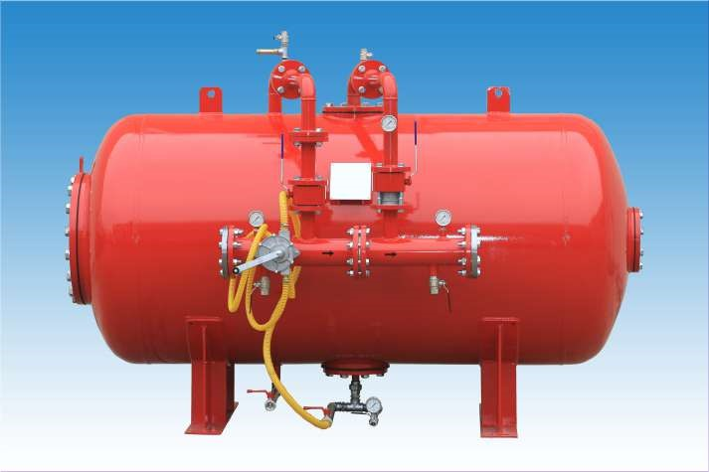
Caracteristici tehnice constructive | Technical construction data
- Norma: 2014/68/UE (Ex. PED 97/23/CE), ASME VIII Div.1 la cerere | - Construction code: 2014/68/UE (Ex. PED 97/23/CE), ASME VIII Div.1 on request
- Presiunea de design: 12 bar | - Design pressure: 12 bar
- Presiune maxima: 12 bar | - Max working pressare: 12 bar
- Presiune de test: 18 bar | - Test pressure: 18 bar
- Temperatura de design: -10° + 50°C | - Design temperature: -10° +50°C

Data Sheet N°53

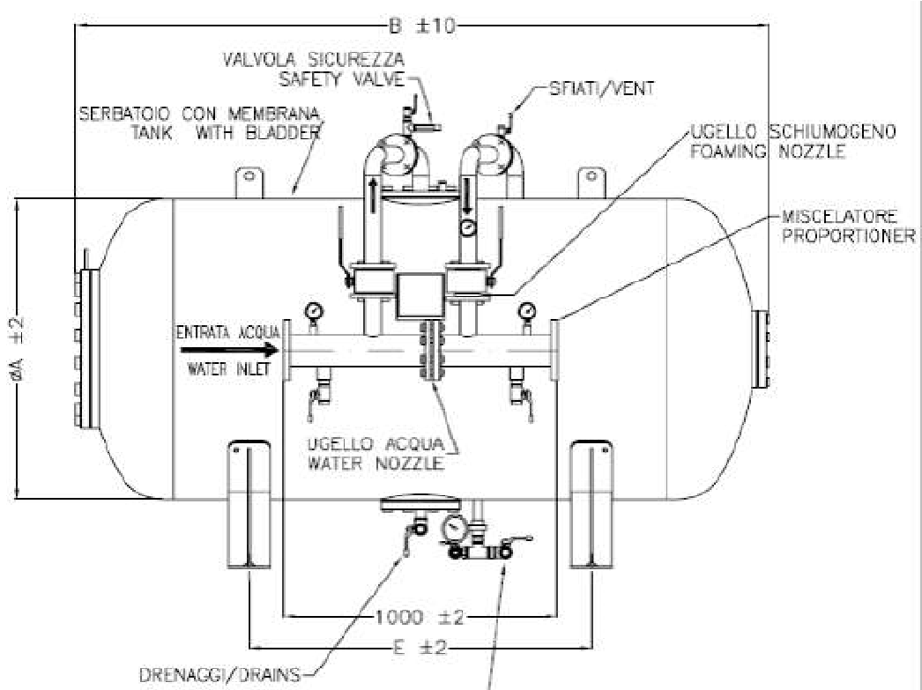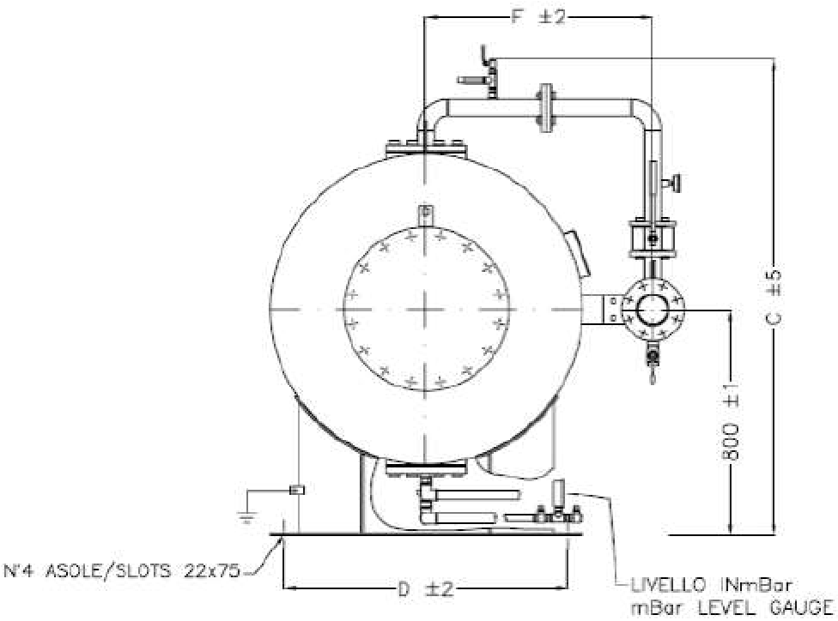

Caracteristici tehnice | Technical construction data
Materiale | Materials
- Capac : P355 NH | - Sheel and head: P355 NH
- Flanse: ASTM A 350 LF2 (UNI o ANSI) | - Flange: ASTM A 350 LF2 (UNI o ANSI)
- Teava: ASTM A 333 Gr.6 | - Pipe: ASTM A 333 Gr.6
- Valve apa si spuma: ASTM A 105 cu sfera in AISI 304 | - Water and foam ball valve:  ASTM A 105 with ball in AISI 304
- Valva de drenaj si scurgere: alama | - Drain and intercept valve: Brass
- Manometru: AISI 304 | - Pressare gauge: AISI 304
- Duze apa si spuma:Otel inoxidabil | - Water and foam nozzles: Brass
- Membrana: Hypalon | - Bladder: Hypalon
Ciclu vopsire | Painting cicle
- Preparare: sablare SA 2,5 | - Surface preparation: sand  blasting SA 2,5
- Prima mana: Epoxivinilic  60 Microns | - Primer: Epoxivinilic 60 Microns
- Final: email poliuretanic 60 Microns  rosu RAL 3000 | - Finish: Enamel poliurethanic 60 Microns red RAL 3000

La cerere rezervoarele se pot furniza cu diferite valori de presiune
On request tanks can be supplied with different pressure values


TABEL DIMENSIUNI

DIMENSIONAL TABLE
MODELLO MODEL | MISU | RE – DIMENSION |  |  |  |  | PESO A VUOTO  Kg.  EMPTY WEIGHT Kg. | CAPACITA’  Lt.  CAPACITY  Lt.
MODELLO MODEL | A | B | C | D | E | F | PESO A VUOTO  Kg.  EMPTY WEIGHT Kg. | CAPACITA’  Lt.  CAPACITY  Lt.
FI-OP 10 | 1000 | 1670 | 1605 | 900 | 700 | 750 | 610 | 1.000
FI-OP 15 | 1000 | 2260 | 1600 | 900 | 1100 | 750 | 710 | 1.500
FI-OP 20 | 1100 | 2525 | 1705 | 1000 | 1250 | 800 | 960 | 2.000
FI-OP 25 | 1170 | 2760 | 1775 | 1000 | 1350 | 800 | 1095 | 2.500
FI-OP 30 | 1270 | 2840 | 1875 | 1150 | 1400 | 860 | 1180 | 3.000
FI-OP 35 | 1360 | 2880 | 1965 | 1200 | 1425 | 900 | 1500 | 3.500
FI-OP 40 | 1450 | 2935 | 2060 | 1250 | 1450 | 950 | 1570 | 4.000
FI-OP 45 | 1450 | 3200 | 2060 | 1250 | 1450 | 950 | 1645 | 4.500
FI-OP 50 | 1600 | 3010 | 2215 | 1400 | 1500 | 1050 | 1745 | 5.000
FI-OP 55 | 1600 | 3225 | 2215 | 1400 | 1500 | 1050 | 1815 | 5.500
FI-OP 60 | 1750 | 3095 | 2365 | 1500 | 1500 | 1150 | 1920 | 6.000
FI-OP 65 | 1750 | 3210 | 2365 | 1500 | 1500 | 1150 | 1960 | 6.500
FI-OP 70 | 1750 | 3445 | 2365 | 1500 | 1900 | 1150 | 2100 | 7.000
FI-OP 75 | 1750 | 3655 | 2365 | 1500 | 1900 | 1150 | 2350 | 7.500
FI-OP 80 | 1960 | 3225 | 2575 | 1700 | 1500 | 1250 | 2230 | 8.000
FI-OP 85 | 1960 | 3375 | 2575 | 1700 | 1650 | 1250 | 2325 | 8.500
FI-OP 90 | 2100 | 3305 | 2710 | 1850 | 1500 | 1300 | 2850 | 9.000
FI-OP 100 | 2200 | 3365 | 2810 | 1950 | 1500 | 1350 | 3035 | 10.000
FI-OP 110 | 2200 | 3495 | 2810 | 1950 | 1500 | 1350 | 3120 | 11.000
FI-OP 120 | 2200 | 3765 | 2810 | 1950 | 1900 | 1350 | 3300 | 12.000
FI-OP 130 | 2200 | 4035 | 2870 | 1950 | 2150 | 1350 | 3190 | 13.000
FI-OP 140 | 2200 | 4365 | 2870 | 1950 | 2480 | 1350 | 3370 | 14.000
FI-OP 150 | 2200 | 4615 | 2870 | 1950 | 2730 | 1350 | 3500 | 15.000

