BLADDER TANK ORIZONTAL PENTRU SPUMA CU MEMBRANA INTERNA
HORIZONTAL FOAM BLADDER TANK INTERNAL MEMBRANE
Mod. FI-OPI

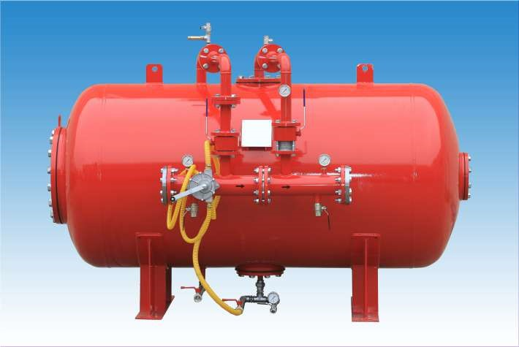
Caracteristici tehnice | Technical construction data
- Norma: 2014/68/UE (Ex. PED 97/23/CE), ASME VIII Div.1 la cerere | - Construction code: 2014/68/UE (Ex. PED 97/23/CE), ASME VIII Div.1 on request
- Presiune de design: 12 bar | - Design pressure: 12 bar
- Presiune maxima de lucru: 12 bar | - Max working pressare: 12 bar
- Presiune de testare: 18 bar | - Test pressure: 18 bar
- Temperatura de design: -10° + 50°C | - Design temperature: -10° +50°C
Data Sheet N°52

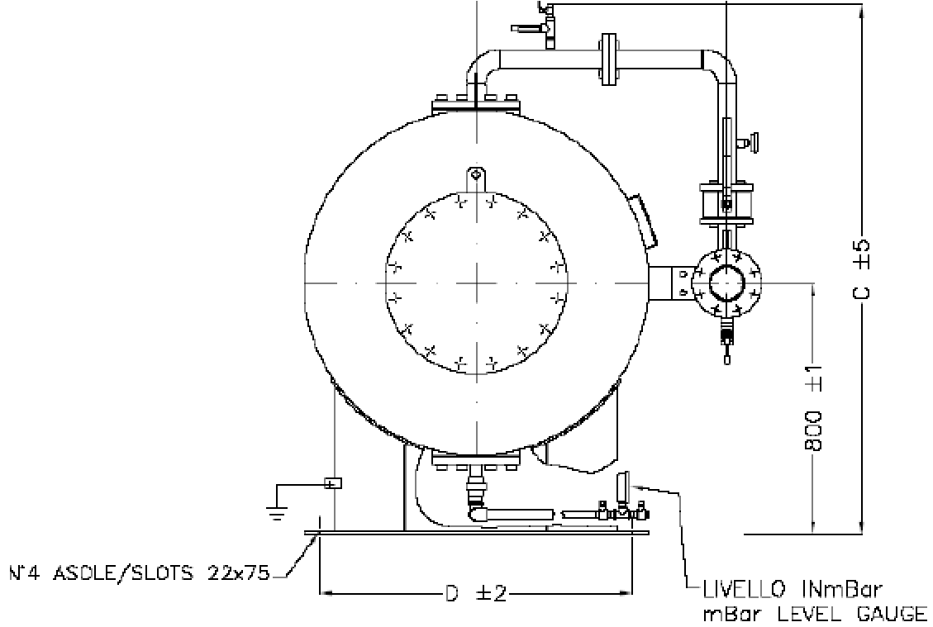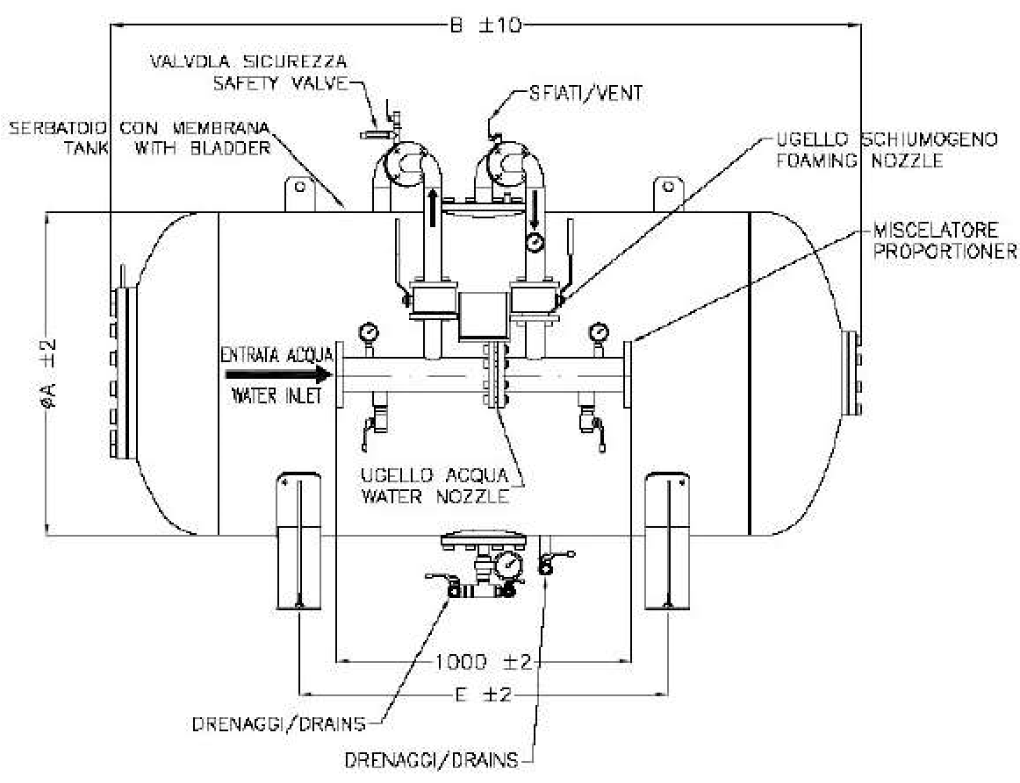

T
ABELLA DIMENSIONALE

DIMENSIONAL TABLE

Caracteristici tehnice constructive | Technical construction data
Material | Materials
- Capac : P355 NH | - Sheel and head: P355 NH
- Flanse: ASTM A 350 LF2 (UNI o ANSI) | - Flange: ASTM A 350 LF2 (UNI o ANSI)
- Teava: ASTM A 333 Gr.6 | - Pipe: ASTM A 333 Gr.6
- Valva apa si spuma: ASTM A 105 cu sfera in AISI 304 | - Water and foam ball valve:  ASTM A 105 with ball in AISI 304
- Valva de drenaj si scurgere: Alama | - Drain and intercept valve: Brass
- Manometru: AISI 304 | - Pressare gauge: AISI 304
- Duza apa si spuma: Otel inoxidabil | - Water and foam nozzles: stainless steel
- Membrana: Hypalon | - Bladder: Hypalon
Ciclu vopsire | Painting cicle
- Preparare: sablare SA 2,5 | - Surface preparation: sand  blasting SA 2,5
- Prima mana: Epoxivinilic  60 Microns | - Primer: Epoxivinilic 60 Microns
- Final: Email poliuretanic 60 Microns  rosu RAL 3000 | - Finish: Enamel poliurethanic 60 Microns red RAL 3000

La cerere rezervoarele se pot furniza cu diferite valori de presiune
On request tanks can be supplied with different pressure values

TABEL DIMENSIUNI
DIMENSIONAL TABLE
MODEL MODEL | DIMENSIUNE | – DIMENSION |  |  |  |  | GREUTATE  Kg.  EMPTY WEIGHT Kg. | CAPACITATE  Lt.  CAPACITY  Lt.
MODEL MODEL | A | B | C | D | E | F | GREUTATE  Kg.  EMPTY WEIGHT Kg. | CAPACITATE  Lt.  CAPACITY  Lt.
FI-OPI 10 | 1000 | 1670 | 1605 | 900 | 700 | 750 | 610 | 1.000
FI-OPI 15 | 1000 | 2260 | 1600 | 900 | 1100 | 750 | 710 | 1.500
FI-OPI 20 | 1100 | 2525 | 1705 | 1000 | 1250 | 800 | 960 | 2.000
FI-OPI 25 | 1170 | 2760 | 1775 | 1000 | 1350 | 800 | 1095 | 2.500
FI-OPI 30 | 1270 | 2840 | 1875 | 1150 | 1400 | 860 | 1180 | 3.000
FI-OPI 35 | 1360 | 2880 | 1965 | 1200 | 1425 | 900 | 1500 | 3.500
FI-OPI 40 | 1450 | 2935 | 2060 | 1250 | 1450 | 950 | 1570 | 4.000
FI-OPI 45 | 1450 | 3200 | 2060 | 1250 | 1450 | 950 | 1645 | 4.500
FI-OPI 50 | 1600 | 3010 | 2215 | 1400 | 1500 | 1050 | 1745 | 5.000
FI-OPI 55 | 1600 | 3225 | 2215 | 1400 | 1500 | 1050 | 1815 | 5.500
FI-OPI 60 | 1750 | 3095 | 2365 | 1500 | 1500 | 1150 | 1920 | 6.000
FI-OPI 65 | 1750 | 3210 | 2365 | 1500 | 1500 | 1150 | 1960 | 6.500
FI-OPI 70 | 1750 | 3445 | 2365 | 1500 | 1900 | 1150 | 2100 | 7.000
FI-OPI 75 | 1750 | 3655 | 2365 | 1500 | 1900 | 1150 | 2350 | 7.500
FI-OPI 80 | 1960 | 3225 | 2575 | 1700 | 1500 | 1250 | 2230 | 8.000
FI-OPI 85 | 1960 | 3375 | 2575 | 1700 | 1650 | 1250 | 2325 | 8.500
FI-OPI 90 | 2100 | 3305 | 2710 | 1850 | 1500 | 1300 | 2850 | 9.000
FI-OPI 100 | 2200 | 3365 | 2810 | 1950 | 1500 | 1350 | 3035 | 10.000
FI-OPI 110 | 2200 | 3495 | 2810 | 1950 | 1500 | 1350 | 3120 | 11.000
FI-OPI 120 | 2200 | 3765 | 2810 | 1950 | 1900 | 1350 | 3300 | 12.000
FI-OPI 130 | 2200 | 4035 | 2870 | 1950 | 2150 | 1350 | 3190 | 13.000
FI-OPI 140 | 2200 | 4365 | 2870 | 1950 | 2480 | 1350 | 3370 | 14.000
FI-OPI 150 | 2200 | 4615 | 2870 | 1950 | 2730 | 1350 | 3500 | 15.000

