BLADDER TANK ORIZONTAL PENTRU SPUMA CU MEMBRANA CERTIFICAT UL
UL LISTED HORIZONTAL FOAM BLADDER TANKS

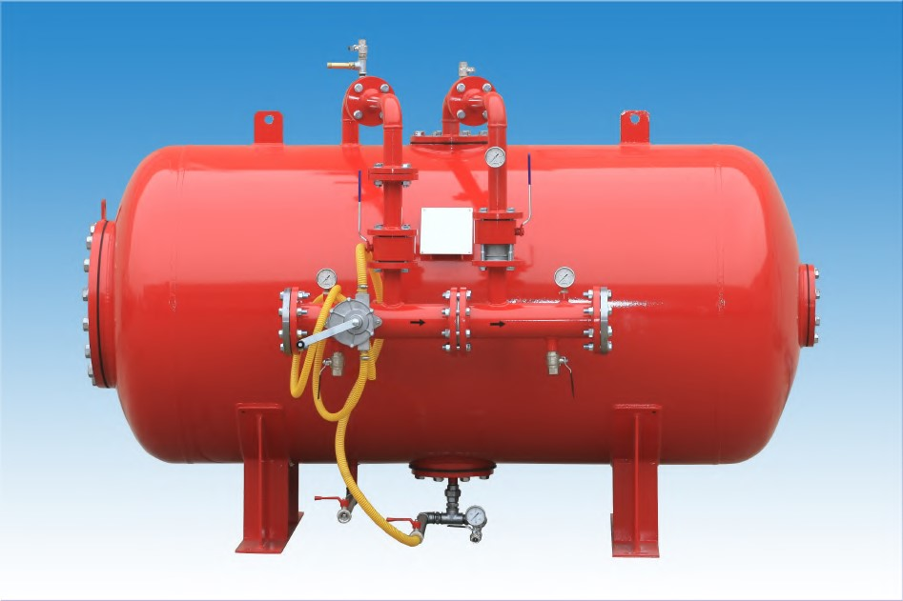
Carateristici tehnice constructive | Technical construction data
- Norma : ASME VIII Div.1 | - Construction code: ASME VIII Div.1
- Presiune de desing 12 bar | - Design pressure std. : 12 bar
- Presiune maxima de lucru:12 bar | - Max. working pressare std.: 12 bar
- Presiune de testare: 18 bar | - Test pressure std.: 18 bar
- Temperatura de design: -10° + 50°C | - Design temperature: -10° +50°C
La cerere rezervoarele se pot livra | - On request the tanks can be
cu diferite valori de presiune manufactured with different pressure
values

Caracteristici tehnice constructive | Technical construction data
Material | Materials
- Capac: ASTM A 516 GR. 70 | - Heads and vessel: ASTM A 516 GR.70
- Flanse: ASTM A 105/A Gr.B | - Flanges: ASTM A 105/A Gr.B
- Teava: ASTM A 106 Gr.B | - Pipe: ASTM A 106 Gr.B
- Valva apa si spuma: ASTM A 105 cu sfera in AISI 304 | - Water and foam ball valve:  ASTM A 105 with ball in AISI 304
- Valva de drenaj si scurgere: Alama | - Drain and intercept valve: Brass
- Manometru: AISI 304 | - Pressare gauge: AISI 304
- Duze apa si spuma:Otel inoxidabil | - Water and foam nozzles: St.steel
- Membrana: caiciuc armat | - Bladder: reinforced rubber
Ciclu de vopsire certificat C3H: | Certified painting cicle C3H:
- Preparare: sablare SA 2,5 | - Surface preparation: sand blasting SA 2,5
- Prima mana: grund epoxidic bicomponent | - Primer: two component epoxy primer
- Final: two component acrylic polyurethane finish | - Finish: two component acrylic polyurethane finish
- Grosime finala 180 micron | - Tot. thickness 180 micron
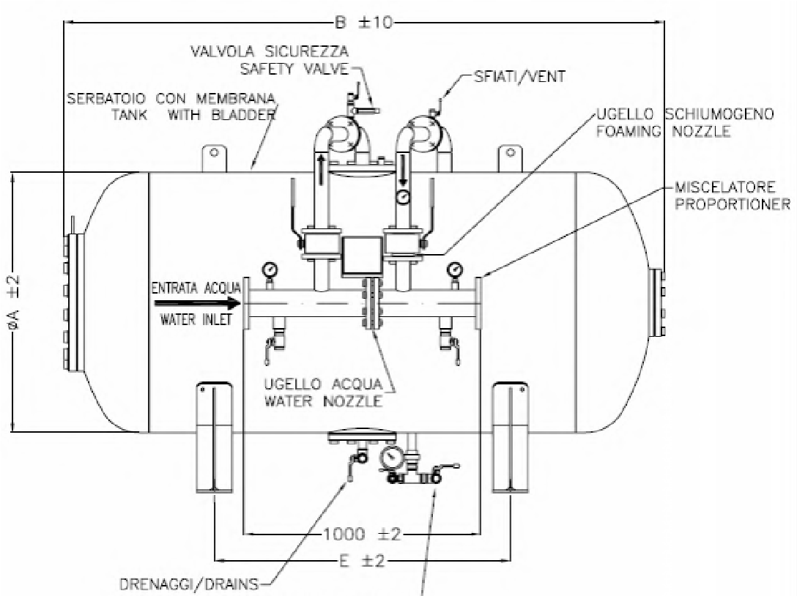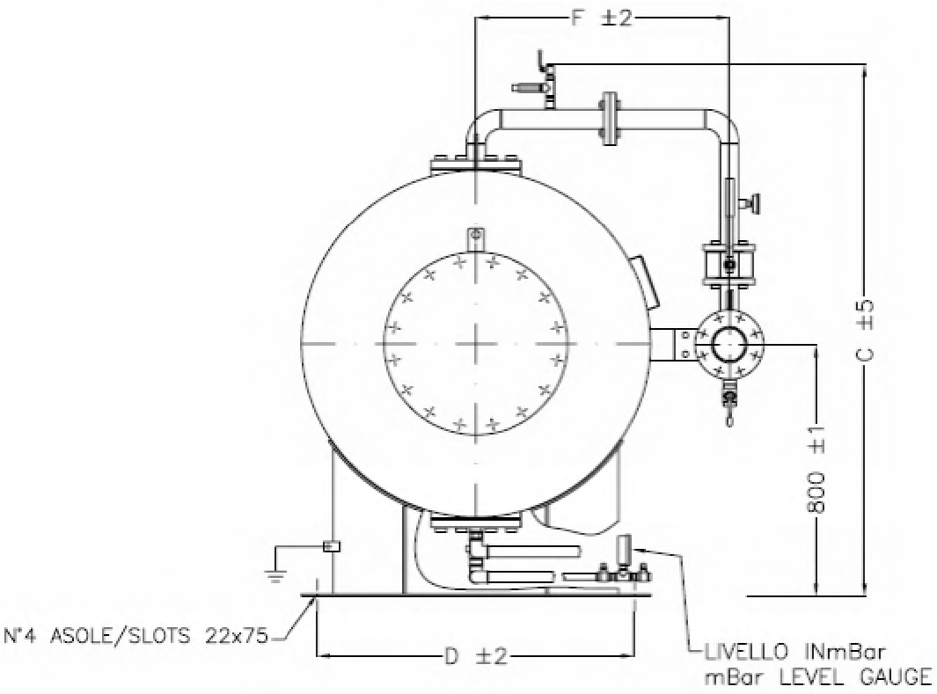

TABELLA DIMENSIUNI

DIMENSIONAL TABLE
MODELLO MODEL | MISURE – DIMENSIONS |  |  |  |  | MAX. PESO VUOTO Kg.  MAX.  EMPTY  WEIGHT Kg. | CAPACITA’  NOMINALE USG  NOMINAL  CAPACITY USG | CAPACITA’  NOMINALE  Lt.  NOMINAL  CAPACITY  Lt.
MODELLO MODEL | A | B | C | D | E | MAX. PESO VUOTO Kg.  MAX.  EMPTY  WEIGHT Kg. | CAPACITA’  NOMINALE USG  NOMINAL  CAPACITY USG | CAPACITA’  NOMINALE  Lt.  NOMINAL  CAPACITY  Lt.
FI-OPI-UL 50 | 500 | 1280 | 1382 | 550 | 600 | 382 | 50 | 190
FI-OPI-UL 75 | 700 | 1055 | 1485 | 700 | 400 | 395 | 75 | 284
FI-OPI-UL 100 | 700 | 1343 | 1370 | 660 | 600 | 426 | 100 | 379
FI-OPI-UL 150 | 800 | 1482 | 1470 | 800 | 650 | 554 | 150 | 568
FI-OPI-UL 200 | 800 | 1902 | 1470 | 800 | 900 | 602 | 200 | 757
FI-OPI-UL 250 | 1000 | 1600 | 1654 | 900 | 660 | 653 | 250 | 947
FI-OPI-UL 300 | 1000 | 1952 | 1654 | 900 | 800 | 685 | 300 | 1136
FI-OPI-UL 350 | 1000 | 2103 | 1654 | 900 | 900 | 705 | 350 | 1325
FI-OPI-UL 400 | 1000 | 2350 | 1654 | 900 | 1100 | 737 | 400 | 1514
FI-OPI-UL 450 | 1000 | 2600 | 1654 | 900 | 1200 | 770 | 450 | 1704
FI-OPI-UL 500 | 1100 | 2433 | 1756 | 1000 | 1200 | 877 | 500 | 1893
FI-OPI-UL 600 | 1170 | 2576 | 1828 | 1000 | 1350 | 949 | 600 | 2271
FI-OPI-UL 700 | 1270 | 2573 | 1930 | 1150 | 1350 | 980 | 700 | 2650

MODELLO MODEL | MISURE – DIMENSIONS |  |  |  |  | MAX. PESO VUOTO Kg.  MAX.  EMPTY  WEIGHT Kg. | CAPACITA’  NOMINALE USG  NOMINAL  CAPACITY USG | CAPACITA’  NOMINALE  Lt.  NOMINAL  CAPACITY  Lt.
MODELLO MODEL | A | B | C | D | E | MAX. PESO VUOTO Kg.  MAX.  EMPTY  WEIGHT Kg. | CAPACITA’  NOMINALE USG  NOMINAL  CAPACITY USG | CAPACITA’  NOMINALE  Lt.  NOMINAL  CAPACITY  Lt.
FI-OPI-UL 800 | 1270 | 2873 | 1930 | 1150 | 1400 | 1038 | 800 | 3028
FI-OPI-UL 900 | 1360 | 2845 | 2024 | 1200 | 1400 | 1135 | 900 | 3407
FI-OPI-UL 1000 | 1450 | 2808 | 2114 | 1250 | 1450 | 1253 | 1000 | 3785
FI-OPI-UL 1100 | 1450 | 2978 | 2114 | 1250 | 1450 | 1296 | 1100 | 4164
FI-OPI-UL 1200 | 1450 | 3278 | 2114 | 1250 | 1450 | 1374 | 1200 | 4542
FI-OPI-UL 1300 | 1600 | 3008 | 2265 | 1400 | 1450 | 1591 | 1300 | 4921
FI-OPI-UL 1400 | 1600 | 3188 | 2265 | 1400 | 1450 | 1650 | 1400 | 5299
FI-OPI-UL 1500 | 1600 | 3378 | 2265 | 1400 | 1450 | 1711 | 1500 | 5678
FI-OPI-UL 1600 | 1750 | 3107 | 2417 | 1500 | 1450 | 1775 | 1600 | 6056
FI-OPI-UL 1700 | 1750 | 3267 | 2417 | 1500 | 1450 | 1831 | 1700 | 6435
FI-OPI-UL 1800 | 1750 | 3407 | 2417 | 1500 | 1450 | 1880 | 1800 | 6813
FI-OPI-UL 1900 | 1750 | 3577 | 2417 | 1500 | 1900 | 1941 | 1900 | 7192
FI-OPI-UL 2000 | 1960 | 3132 | 2676 | 1700 | 1500 | 2383 | 2000 | 7570
FI-OPI-UL 2200 | 1960 | 3382 | 2676 | 1700 | 1500 | 2506 | 2200 | 8327
FI-OPI-UL 2400 | 2100 | 3286 | 2817 | 1850 | 1500 | 2674 | 2400 | 9084
FI-OPI-UL 2600 | 2100 | 3476 | 2817 | 1850 | 1500 | 2776 | 2600 | 9841
FI-OPI-UL 2800 | 2200 | 3438 | 2918 | 1950 | 1500 | 2891 | 2800 | 10598
FI-OPI-UL 3000 | 2200 | 3648 | 2918 | 1950 | 1500 | 3008 | 3000 | 11355
FI-OPI-UL 3200 | 2200 | 3858 | 2918 | 1950 | 1900 | 3124 | 3200 | 12112
FI-OPI-UL 3400 | 2200 | 4078 | 2918 | 1950 | 1900 | 3247 | 3400 | 12869
FI-OPI-UL 3600 | 2200 | 4278 | 2918 | 1950 | 2100 | 3357 | 3600 | 13626
FI-OPI-UL 3800 | 2200 | 4478 | 2918 | 1950 | 2500 | 3467 | 3800 | 14383
FI-OPI-UL 4000 | 2200 | 4678 | 2918 | 1950 | 2700 | 3579 | 4000 | 15140

